**Elastic Beanstalk:**

* We can deploy and maintain the application on Elastic beanstalk.
* We can run the code and we need not to worry about infrastructure like servers.

**Deploy application on Elastic Beanstalk by using Code Pipeline:**

* Go to Elastic beanstalk dashboard and first create the application on Elastic beanstalk and create environment.
* While creating environment on elastic beanstalk we can create the role for EC2 in which attach the elastic beanstalk,s3,codecommit policies.
* Download the sample nodejs application from [**https://docs.aws.amazon.com/elasticbeanstalk/latest/dg/samples/nodejs.zip**](https://docs.aws.amazon.com/elasticbeanstalk/latest/dg/samples/nodejs.zip)link into the local machine and extract these files(unzip the files).
* Connect to the ec2 instance by using Putty.
* Configure the AWS Cli by providing access key and secret key and attach the s3full access to the IAM user.
* Create the https git credentials for code commit in IAM user.
* Upload the sample nodejs application files into the S3 bucket.
* Copy the files from S3 bucket to the ec2 instance by using “**aws s3 cp s3://bucketname/filename .”** command.
* Create the repository in code commit and enter the “**git clone repository url”** command on ec2 server.
* Enter **git status** and **git add .** command on ec2 server.
* Enter **git commit -m “commit message”** on ec2 server.
* Enter **git push repositoryurl** on ec2 server.
* Go to code commit and create the pipeline.
* Copy the domain name from elastic beantalk and paste it on browser.
* Now we can access the application.

Created the application environment on elastic beanstalk

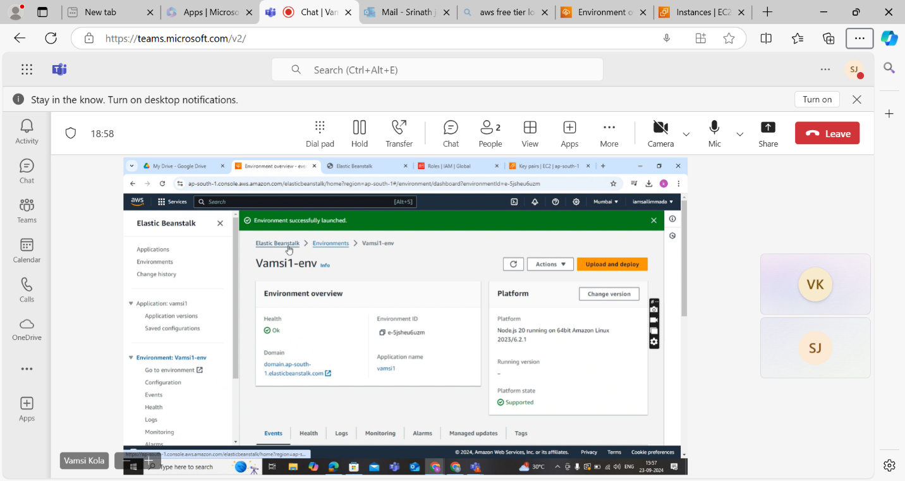

Copy the files and push it to the code commit repo on Ec2 server

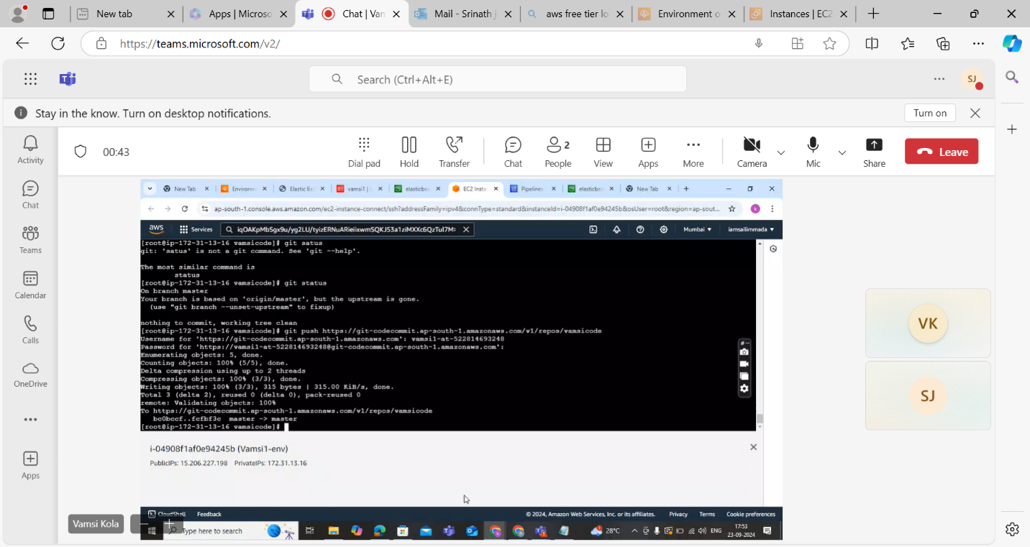

Pileline will be succeded

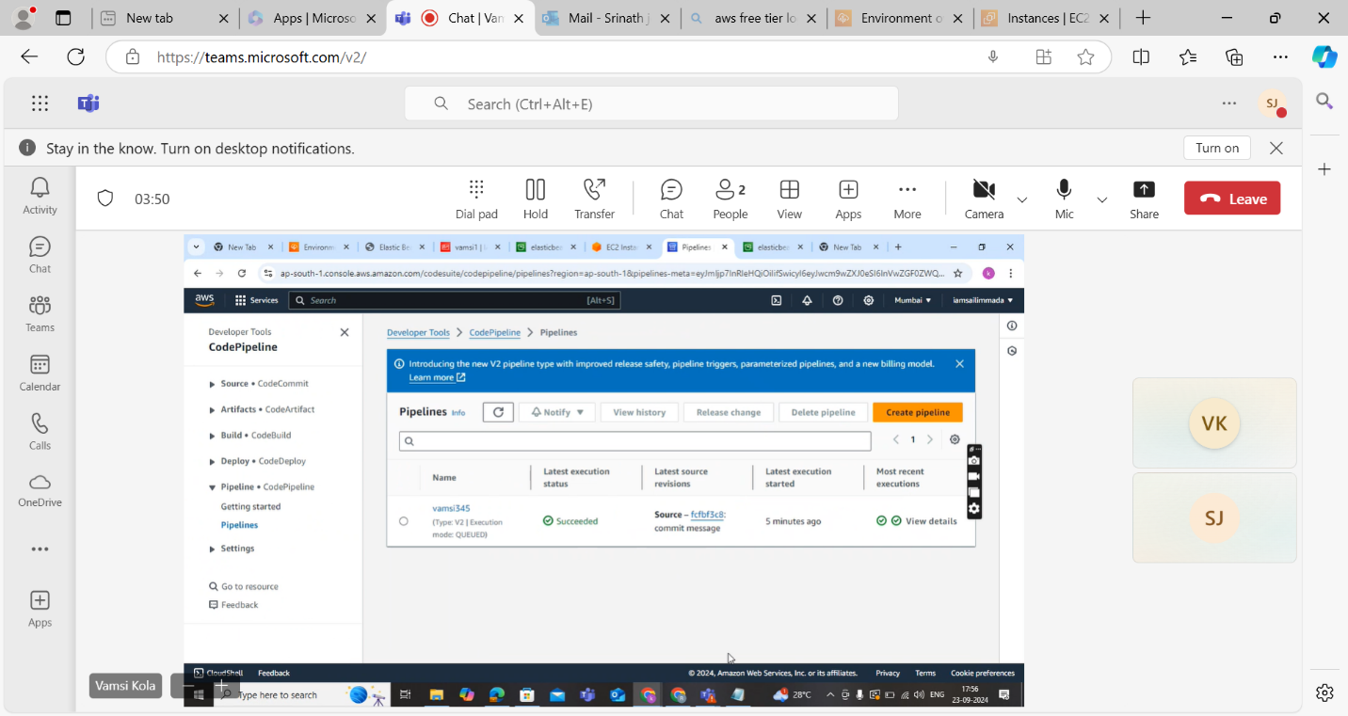

Access the nodejs application by using domain name

